SIMATS ENGINEERING
ASSESSMENT TOOL 2

COURSE NAME: INTERNET PROGRAMMING
COURSE CODE: CSA43

COURSE OUTCOME COVERED
CO -2 : Apply CSS layout and styling techniques to create visually appealing and
responsive web interfaces, and use JavaScript to enable interactive client-side behavior.
(L3)
Assessment Tool : Design Task
Weightage: 20%

QUESTIONS: Total Marks: 20

Question 1: Responsive Navigation Bar Design - Marks(4)
Suppose that an e-commerce website requires a responsive navigation bar that adapts across
desktop, tablet, and mobile devices.
(a) Identify key components required in a navigation bar for an e-commerce website.
(b) Design a responsive navigation bar using appropriate CSS techniques.
(c) Demonstrate how the navigation adapts to smaller screens (e.g., hamburger menu).
(d) Evaluate the usability and suggest improvements for better user experience.

Question 2: Product Hover Effect - Marks(4)
Suppose that an e-commerce website wants to enhance user interaction through visual effects
on product items.
(a) Identify suitable CSS properties for hover effects.
(b) Suggest appropriate CSS animation or transition for product interaction.
(c) Design a hover effect for a product card.
(d) Evaluate performance and user experience considerations.

Question 3: Layout Selection (Flexbox vs Grid) - Marks(4)
Suppose that a dashboard layout needs to be designed for a web application.
(a) Identify layout requirements of a dashboard (rows, columns, alignment).
(b) Compare Flexbox and Grid based on layout needs.
(c) Choose the most suitable layout technique and justify your choice.
(d) Evaluate the scalability and responsiveness of the chosen approach.

Question 4: Mobile-First Blog Layout - Marks(4)
Suppose that a blog page must be designed following a mobile-first approach.
(a) Identify key sections of a blog layout.
(b) Design a mobile-first layout using CSS.
(c) Demonstrate how the layout scales for larger screens using media queries.
(d) Evaluate accessibility and readability of the design.

Question 5: JavaScript Event Handling for Dynamic Menu - Marks(4)
Suppose that a website includes a dynamic menu that responds to user interactions.
(a) Identify appropriate JavaScript events for menu interaction.
(b) Design event handling logic for menu toggle functionality.
(c) Implement interaction for user actions (click/hover).
(d) Evaluate performance and suggest improvements.

Code of Conduct:
I KRITHI JS (192311262) certify that this submission is my
original work and that I have adhered to the guidelines specified for this assessment.
I understand that any violation of academic integrity rules will result in disciplinary
action.
Signature of the student:

QUESTION 1: Responsive Navigation Bar Design (4 Marks)
(a) Key Components Required in an E-Commerce Navigation Bar
A responsive navigation bar helps users access different sections of an e-commerce website easily. The important components include:
- Logo: Represents the brand and links to the homepage.
- Navigation links: Provide access to Home, Products, Categories, Offers, and Contact pages.
- Search bar: Allows users to find products quickly.
- Shopping cart: Displays selected products and the cart count.
- User account: Provides login, registration, and profile options.
- Hamburger menu: Displays navigation links on smaller screens.
(b) Design a Responsive Navigation Bar Using CSS
The following HTML and CSS create a navigation bar that adapts to different screen sizes.
HTML Code
<!DOCTYPE html>
<html>
<head>
<title>Responsive Navigation</title>
<link rel="stylesheet" href="style.css">
</head>
<body>
<nav class="navbar">
<h2 class="logo">ShopEase</h2>
<input type="checkbox" id="menu">
<label for="menu" class="hamburger">☰</label>
<ul class="nav-links">
<li><a href="#">Home</a></li>
<li><a href="#">Products</a></li>
<li><a href="#">Offers</a></li>
<li><a href="#">Contact</a></li>
<li><a href="#">Cart 🛒</a></li>
</ul>
</nav>
</body>
</html>
CSS Code
* {
box-sizing: border-box;
}

body {
margin: 0;
font-family: Arial, sans-serif;
}

.navbar {
display: flex;
justify-content: space-between;
align-items: center;
background: #243447;
color: white;
padding: 15px 25px;
}

.logo {
margin: 0;
}

.nav-links {
display: flex;
gap: 22px;
list-style: none;
margin: 0;
padding: 0;
}

.nav-links a {
color: white;
text-decoration: none;
}

.nav-links a:hover {
color: #ffd166;
}

#menu, .hamburger {
display: none;
}

@media (max-width: 600px) {
.hamburger {
display: block;
cursor: pointer;
font-size: 26px;
}

.nav-links {
display: none;
position: absolute;
top: 60px;
left: 0;
width: 100%;
flex-direction: column;
background: #243447;
padding: 20px;
}

#menu:checked ~ .nav-links {
display: flex;
}
}
(c) Adaptation to Smaller Screens
On desktop screens, navigation links appear horizontally. On mobile devices, the media query hides the links and displays a hamburger icon. When the user selects the icon, the checkbox changes its state and displays the menu vertically.
(d) Usability Evaluation and Improvements
The navigation bar improves accessibility to important website sections and provides a consistent browsing experience. The responsive design reduces clutter on smaller screens. Further improvements include adding keyboard navigation, visible focus indicators, a descriptive label for the hamburger menu, and a search field that adjusts to mobile screens.
Output:

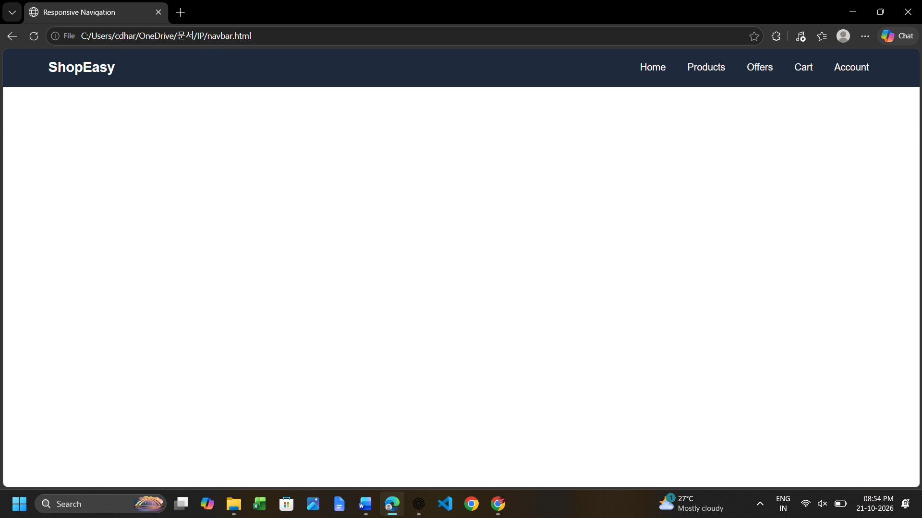
QUESTION 2: Product Hover Effect (4 Marks)
(a) Suitable CSS Properties for Hover Effects
CSS hover effects improve the appearance of product cards when users move their mouse over them. The important properties include:
- transform: Moves, scales, or rotates an element.
- transition: Creates smooth changes between styles.
- box-shadow: Adds depth to product cards.
- opacity: Controls transparency.
- background-color: Changes the background color.
- filter: Applies visual effects such as brightness.
(b) Appropriate CSS Animation or Transition
The transition property is suitable for simple product interactions because it creates smooth visual changes. For example, transition: transform 0.3s ease, box-shadow 0.3s ease; gradually changes the size and shadow of a product card over 0.3 seconds.
(c) Design a Hover Effect for a Product Card
HTML Code
<div class="product-card">
<img src="https://placehold.co/300x200"
alt="Wireless headphones">
<h3>Wireless Headphones</h3>
<p>Price: ₹1,499</p>
<button>Add to Cart</button>
</div>
CSS Code
.product-card {
width: 280px;
padding: 20px;
text-align: center;
border-radius: 12px;
background: white;
box-shadow: 0 3px 10px #cccccc;
transition: transform 0.3s ease,
box-shadow 0.3s ease;
}

.product-card img {
width: 100%;
border-radius: 8px;
}

.product-card:hover {
transform: translateY(-6px);
box-shadow: 0 10px 20px #aaaaaa;
}

.product-card button {
background: #087f5b;
color: white;
border: none;
padding: 10px 16px;
border-radius: 5px;
cursor: pointer;
}

.product-card button:hover {
background: #055f43;
}
(d) Performance and User Experience Considerations
Hover effects make product cards more attractive and help users identify interactive elements. Simple transitions using transform and opacity generally perform well. Excessive animations, large shadows, and complicated effects should be avoided because they may affect performance. Mobile users do not always have hover functionality, so essential information and actions must remain visible without hovering. The design should also respect reduced-motion preferences.
Output:
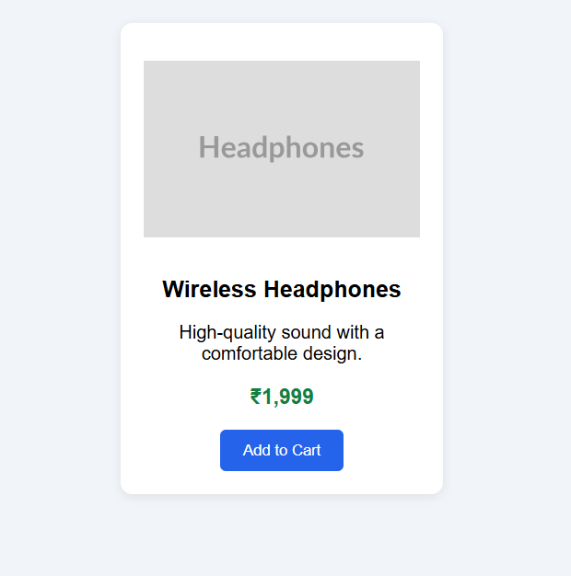
QUESTION 3: Layout Selection – Flexbox vs Grid (4 Marks)
(a) Layout Requirements of a Dashboard
A dashboard typically contains a header, sidebar, main content area, data cards, charts, and a footer. It requires proper alignment, consistent spacing, flexible rows and columns, and responsive resizing. The layout must display information clearly on desktops, tablets, and mobile devices.
(b) Comparison Between Flexbox and Grid
Feature | Flexbox | CSS Grid
Layout type | One-dimensional | Two-dimensional
Arrangement | Row or column | Rows and columns
Alignment | Excellent for linear alignment | Excellent for structured alignment
Spacing | Uses gap and alignment properties | Uses gap and grid placement
Dashboard suitability | Navigation bars and toolbars | Dashboard cards and page structure
(c) Most Suitable Layout Technique and Justification
CSS Grid is the most suitable technique for designing the main dashboard because it manages rows and columns simultaneously. It allows cards, charts, and other sections to be arranged in a consistent structure. Flexbox can be used alongside Grid for the navigation bar and for aligning content inside individual cards.
CSS Code
<div class="dashboard">
<header class="header">Dashboard</header>
<aside class="sidebar">Menu</aside>
<main class="content">
<div class="card">Total Sales</div>
<div class="card">Customers</div>
<div class="card">Orders</div>
<div class="card">Revenue Chart</div>
</main>
</div>
.dashboard {
display: grid;
grid-template-columns: 220px 1fr;
grid-template-rows: 70px 1fr;
min-height: 100vh;
}

.header {
grid-column: 1 / -1;
background: #243447;
color: white;
padding: 20px;
}

.sidebar {
background: #e9ecef;
padding: 20px;
}

.content {
display: grid;
grid-template-columns: repeat(3, minmax(0, 1fr));
gap: 20px;
padding: 20px;
}

.card {
padding: 25px;
background: #f1f3f5;
border-radius: 8px;
}

@media (max-width: 768px) {
.dashboard {
grid-template-columns: 1fr;
}

.sidebar {
display: none;
}

.content {
grid-template-columns: repeat(2, minmax(0, 1fr));
}
}

@media (max-width: 480px) {
.content {
grid-template-columns: 1fr;
}
}
(d) Scalability and Responsiveness Evaluation
CSS Grid makes it easy to add or rearrange dashboard components without manually positioning every element. The minmax() and repeat() functions support flexible layouts, while media queries adapt the number of columns to the screen size. For better scalability, the sidebar can be converted into a collapsible menu on smaller devices instead of being permanently hidden.
Output:
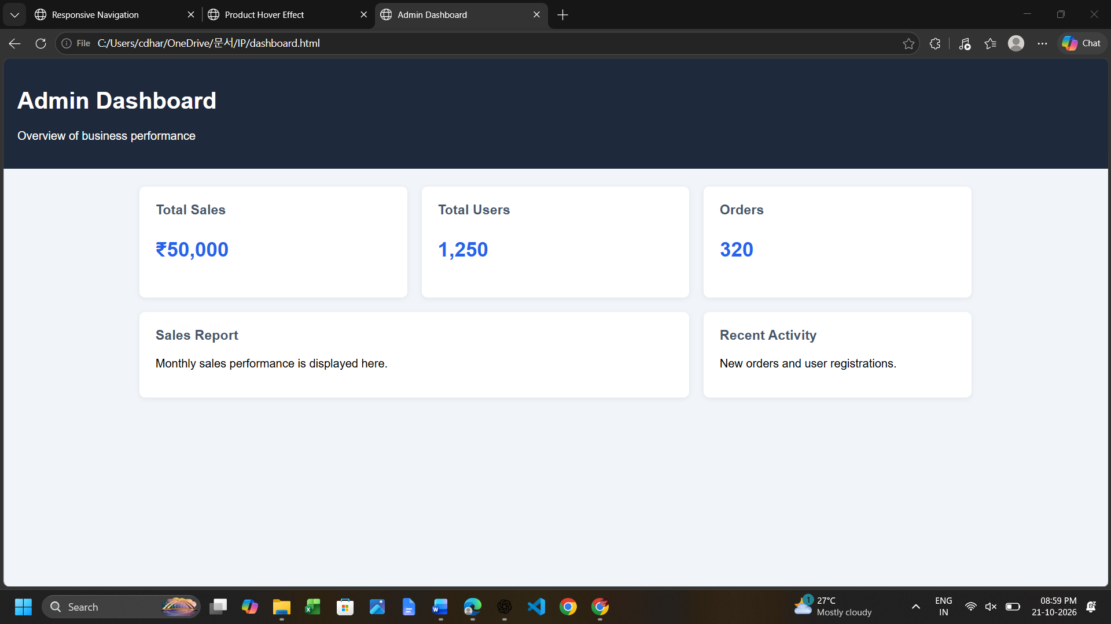
QUESTION 4: Mobile-First Blog Layout (4 Marks)
(a) Key Sections of a Blog Layout
A blog page contains a header with the website title, a navigation menu, a main content area, blog article cards, a sidebar for categories or popular posts, and a footer. Each article card may include a title, image, author, publication date, summary, and a link to read more.
(b) Design a Mobile-First Layout Using CSS
A mobile-first design begins with styles for small screens. Additional layout features are introduced as the available screen width increases.
HTML Code
<!DOCTYPE html>
<html>
<head>
<title>My Blog</title>
<link rel="stylesheet" href="blog.css">
</head>
<body>
<header class="header">
<h1>My Blog</h1>
<nav>
<a href="#">Home</a>
<a href="#">Articles</a>
<a href="#">About</a>
</nav>
</header>

<div class="layout">
<main class="posts">
<article class="post">
<h2>Technology and Daily Life</h2>
<p>Explore how technology makes everyday tasks easier.</p>
<a href="#">Read More</a>
</article>

<article class="post">
<h2>Healthy Living Tips</h2>
<p>Discover simple habits for a healthier lifestyle.</p>
<a href="#">Read More</a>
</article>
</main>

<aside class="sidebar">
<h3>Categories</h3>
<p>Technology</p>
<p>Lifestyle</p>
</aside>
</div>

<footer class="footer">
<p>© 2026 My Blog</p>
</footer>
</body>
</html>
(c) Scaling for Larger Screens Using Media Queries
* {
box-sizing: border-box;
}

body {
margin: 0;
font-family: Cambria, serif;
line-height: 1.6;
color: #222;
}

.header, .footer {
background: #243447;
color: white;
padding: 18px;
text-align: center;
}

nav a {
color: white;
margin: 8px;
text-decoration: none;
}

.layout {
display: grid;
grid-template-columns: 1fr;
gap: 20px;
padding: 16px;
}

.post {
padding: 18px;
margin-bottom: 16px;
background: #f5f5f5;
border-radius: 8px;
}

.post a {
color: #075e9b;
}

@media (min-width: 768px) {
.layout {
grid-template-columns: 2fr 1fr;
max-width: 1100px;
margin: auto;
padding: 24px;
}
}

@media (min-width: 1200px) {
.layout {
gap: 30px;
}

.post {
padding: 24px;
}
}
(d) Accessibility and Readability Evaluation
The mobile-first approach improves readability by presenting content in a single column on smaller screens. Larger text, sufficient line spacing, suitable color contrast, and meaningful HTML elements improve accessibility. Images should include descriptive alternative text, links should have clear labels, and the website should support keyboard navigation. Text width should also be limited on large screens to prevent long lines from becoming difficult to read.
Output:
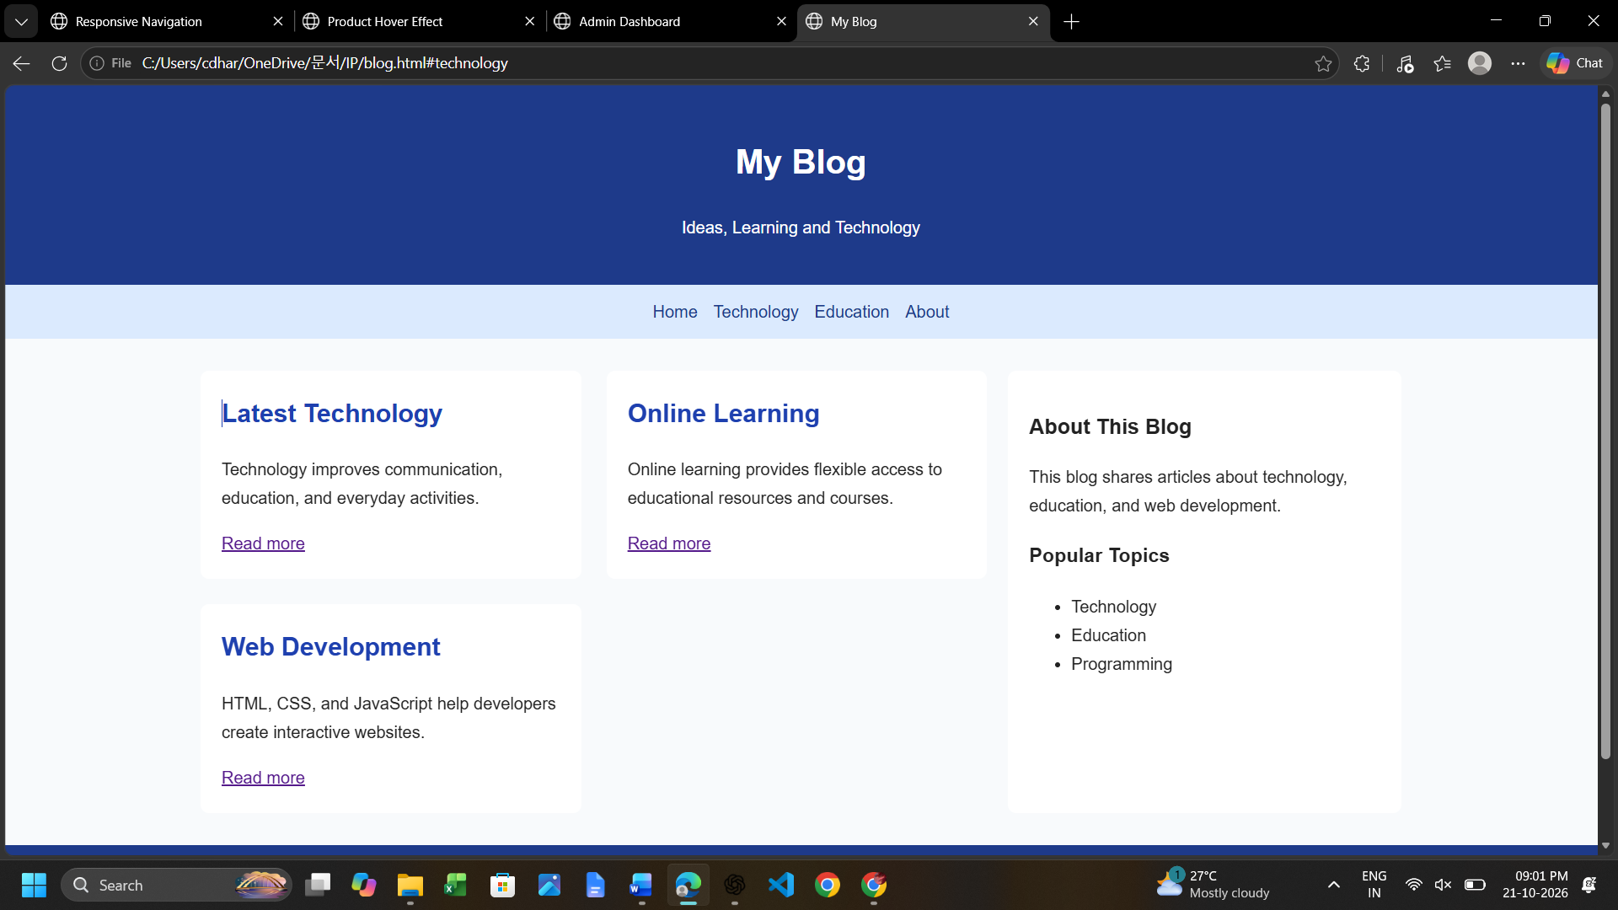
QUESTION 5: JavaScript Event Handling for Dynamic Menu (4 Marks)
(a) Appropriate JavaScript Events for Menu Interaction
JavaScript events allow a menu to respond to user actions. Common events include:
- click: Opens or closes the menu when the user clicks a button.
- mouseover: Detects when the mouse enters an element.
- mouseout: Detects when the mouse leaves an element.
- keydown: Supports keyboard interactions such as Escape.
- focus and blur: Detect when an element receives or loses keyboard focus.
For responsive menus, the click event is usually the best primary interaction because it works on both touchscreens and desktop devices.
(b) Event Handling Logic for Menu Toggle Functionality
The menu toggle logic uses a Boolean state to determine whether the menu is open or closed. When the toggle button is clicked, JavaScript updates the menu's visibility and the button's accessibility attributes. Pressing Escape closes the menu.
(c) Implementing Click and Hover Interactions
HTML Code
<!DOCTYPE html>
<html>
<head>
<title>Dynamic Menu</title>
<link rel="stylesheet" href="menu.css">
</head>
<body>

<button id="menuButton"
aria-expanded="false"
aria-controls="menuList">
☰ Menu
</button>

<ul id="menuList" class="menu">
<li><a href="#">Home</a></li>
<li><a href="#">Products</a></li>
<li><a href="#">Services</a></li>
<li><a href="#">Contact</a></li>
</ul>

<script src="menu.js"></script>
</body>
</html>
CSS Code
body {
font-family: Arial, sans-serif;
}

#menuButton {
padding: 10px 16px;
cursor: pointer;
background: #243447;
color: white;
border: none;
border-radius: 5px;
}

.menu {
display: none;
list-style: none;
padding: 0;
width: 200px;
background: #f1f3f5;
}

.menu.open {
display: block;
}

.menu a {
display: block;
padding: 12px;
color: #222;
text-decoration: none;
}

.menu a:hover,
.menu a:focus {
background: #dbeafe;
}
JavaScript Code
const button = document.getElementById("menuButton");
const menu = document.getElementById("menuList");

function setMenu(open) {
menu.classList.toggle("open", open);
button.setAttribute("aria-expanded", String(open));
}

button.addEventListener("click", function () {
const isOpen = button.getAttribute("aria-expanded") === "true";
setMenu(!isOpen);
});

document.addEventListener("keydown", function (event) {
if (event.key === "Escape") {
setMenu(false);
button.focus();
}
});
In this implementation, clicking the menu button opens or closes the menu. The mouseover and mouseout events are not necessary for the basic toggle because click interaction is more reliable across desktop and mobile devices. CSS :hover and :focus provide visual feedback when users interact with menu links.
(d) Performance Evaluation and Improvements
JavaScript event handling makes menus interactive and improves navigation. Using addEventListener() separates behavior from HTML and makes the code easier to maintain. Event listeners should be added only when needed, and unnecessary DOM updates should be avoided. Accessibility can be improved by supporting keyboard controls, updating aria-expanded, maintaining visible focus indicators, and ensuring that the menu works on touchscreens. For complex menus, additional logic can close the menu when a user selects a link or clicks outside it.
Output:
